Quiz 2 (Database Systems Lab)

Name = Poorab Gangwani

Class = 4B1

Roll-Number = CS191092

Q1)

a)

**Create the following tables and set their primary keys:**

**Games(ID, name, genre, released, rating, price, publisherID, platformID)**

**Publishers(ID, name, locationID)**

**Platforms(ID, name, price)**

**Locations(ID, city, country)**

**Show the structures of all the tables. (Hint: Use the data provided to decide data types.)**

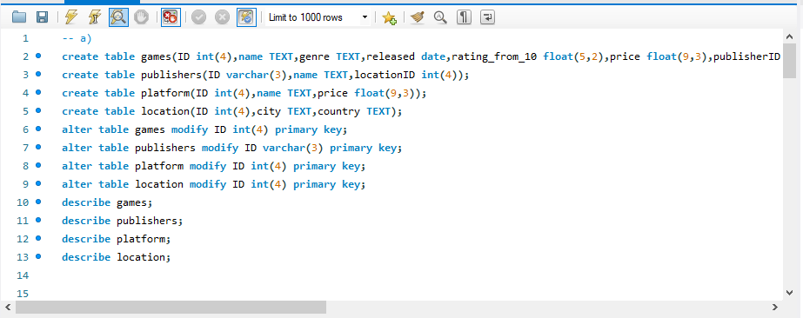

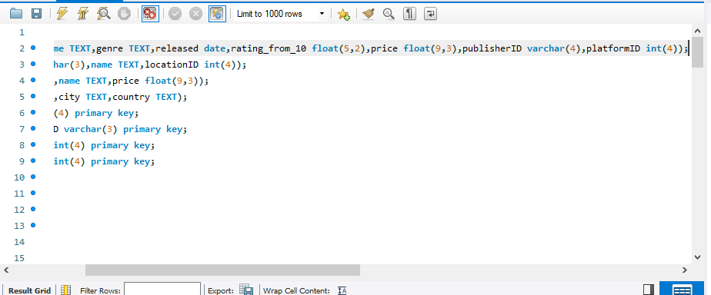

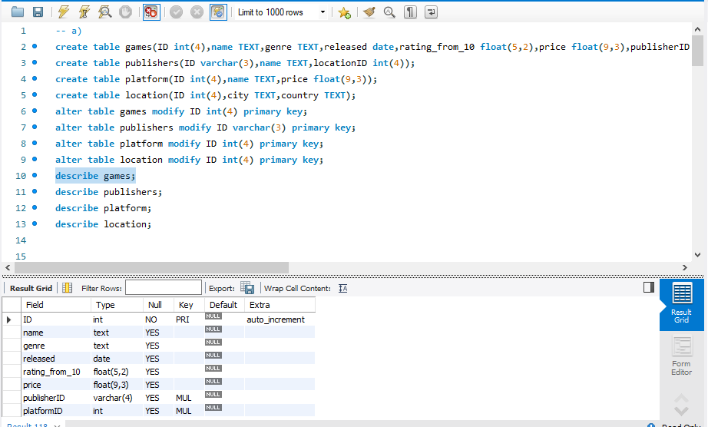

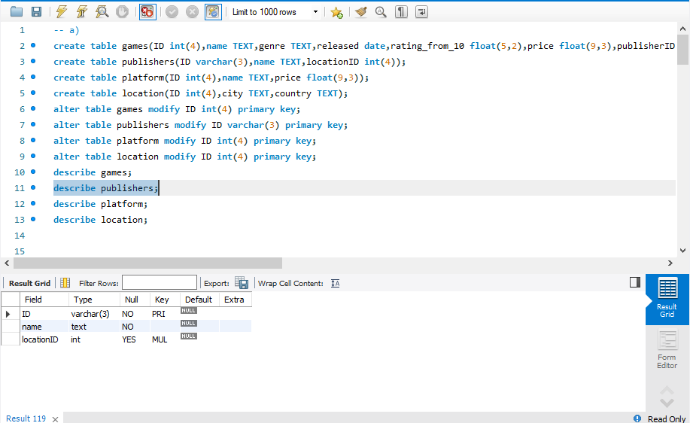

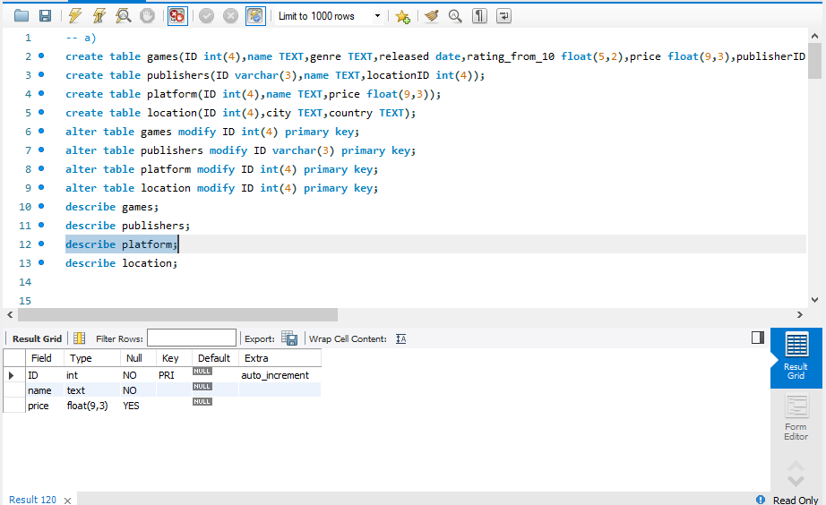

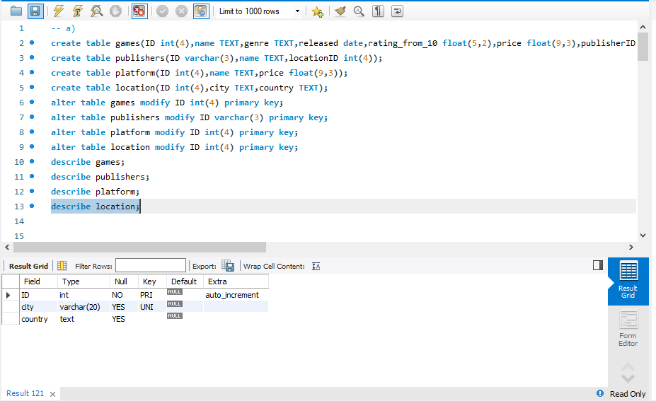

b) **Ensure that platform names and publisher names can never be empty. Also set all numeric IDs to increment automatically.**

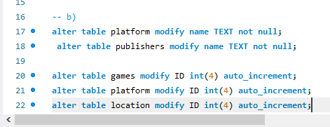

c) **Ensure that a city name can never be repeated.**

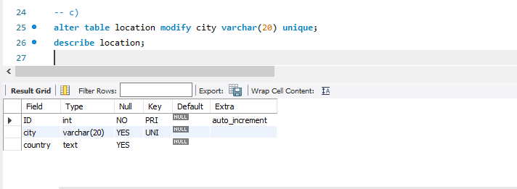

d) **Insert the given data into the tables.**

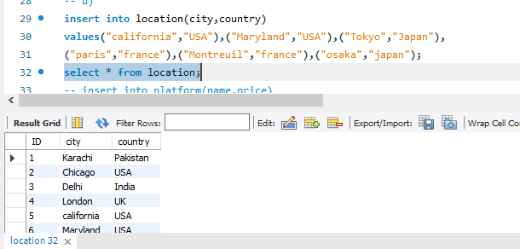

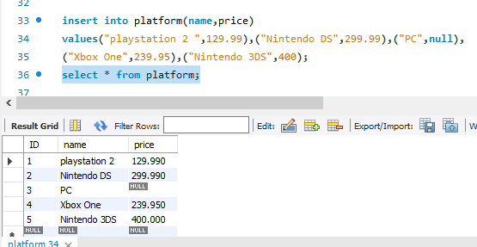

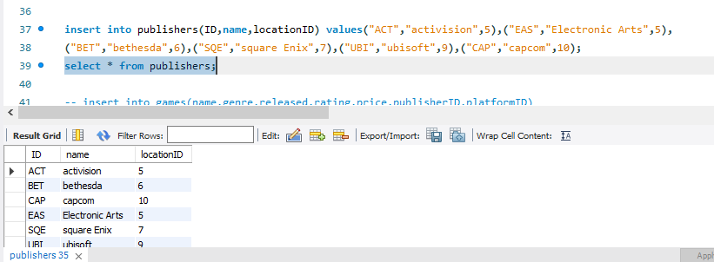

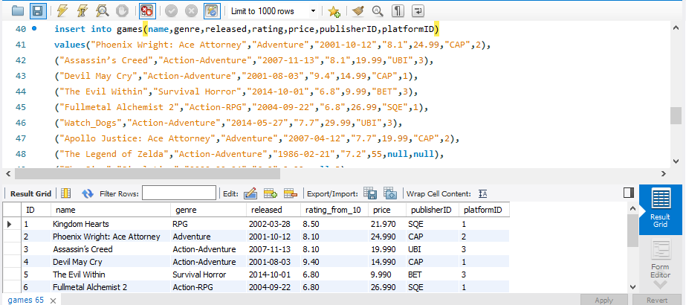

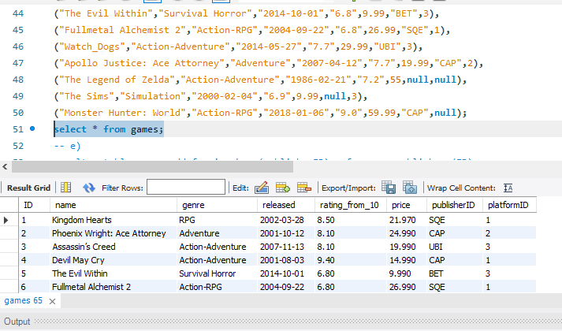

e) **Set appropriate foreign keys while ensuring that whenever a platform is deleted, the games for that platform should also be deleted.**

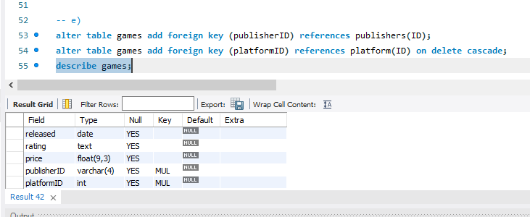

f) **Set any other appropriate foreign keys.**

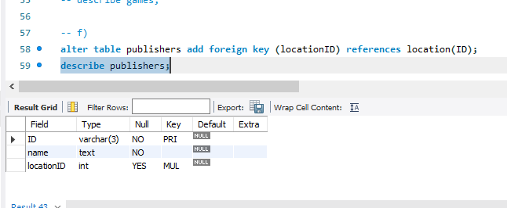

Q2)

1. **Display the three lowest rated games. Also display their ratings**

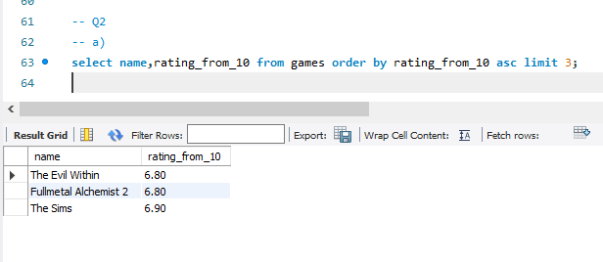

1. **Display a list of all the adventure games (including multi-genre games) that were released before 2005.**

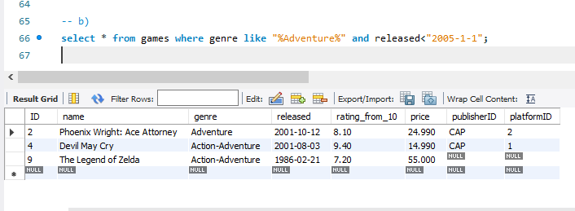

1. **Display the genre with the third highest number of games. Label appropriately.**

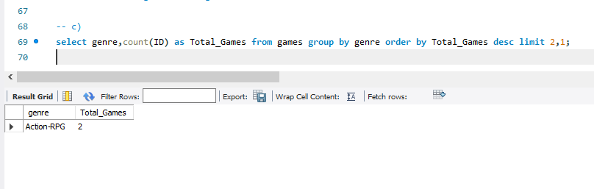

1. **For each game, give the number of years that have passed since its release. List them from the most recent to the least recent.**

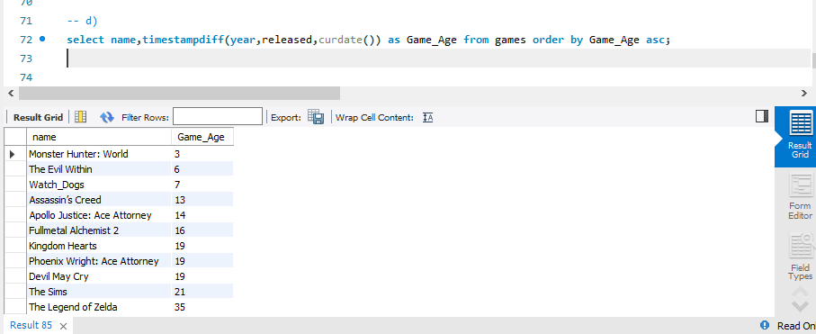

1. **Display the game name, publisher name, and platform name for each game. Label appropriately.**

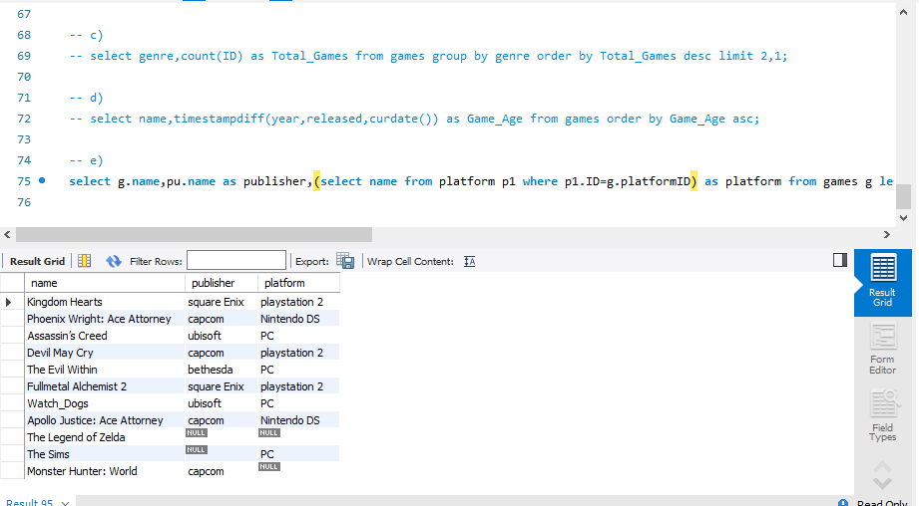

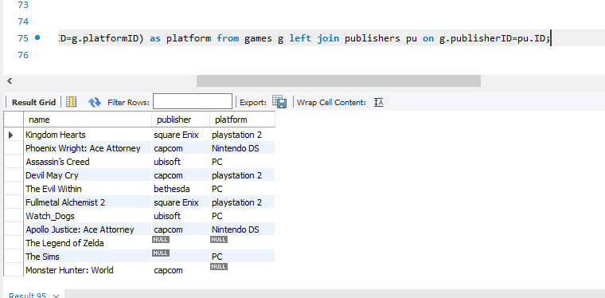

1. **Give the total number of games of each genre published by each publisher.**

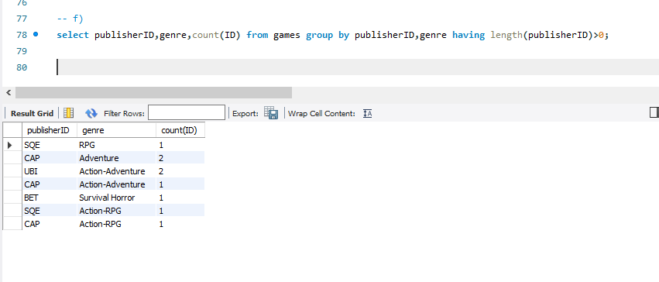

1. **Create a temporary table FullGameInfo having game ID, game name, genre, publisher name, and platform name. The table should include all the games. Label all ambiguous fields appropriately. Display all the records of this new table.**

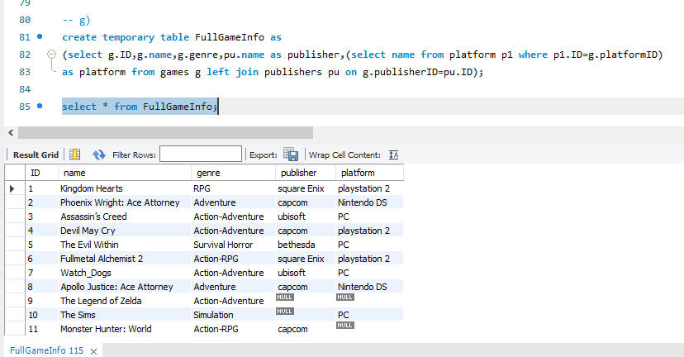

1. **Delete all games without a platform from FullGameInfo.**

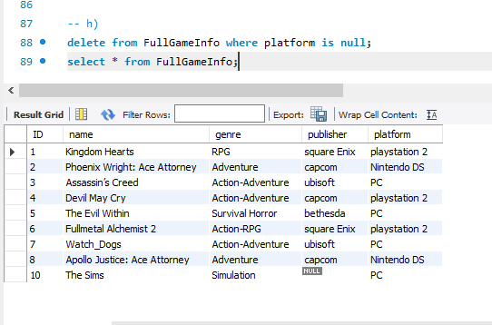

1. **Delete the genre column from FullGameInfo and add a new column “ESRB” before publisher name.**

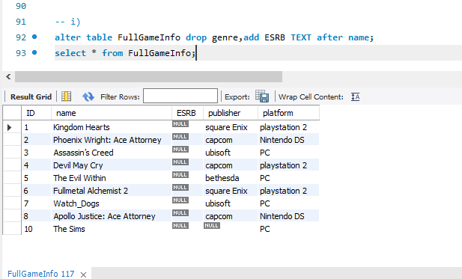

1. **Delete the table FullGameInfo and using a select query to ensure that your table is deleted.**

